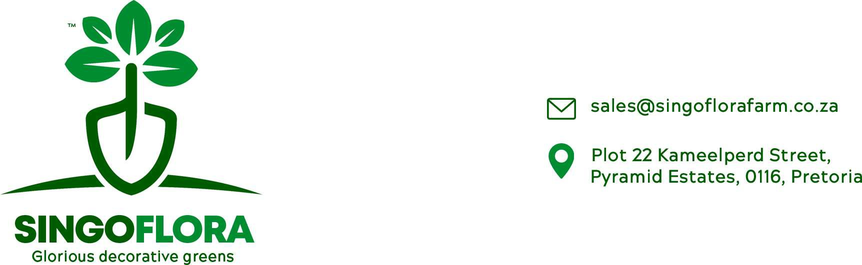

Price List 2022

|  |  |  |  |
| --- | --- | --- | --- |
| Product | Min Oder | Stems per Bunch | Price per Bunch |
| Sperengi | 1 | 10 | R11.00 |
| Flax | 1 | 10 | R9.40 |
| Leather leaf | 5 | 20 | R9.40 |
| Nephrolepus | 5 | 10 | R9.40 |
| Pennygum | 1 | 10 | R11.00 |
| Ruscus | 5 | 10 | R11.00 |
| EX-Ruscus | 5 | 10 | R13.00 |
| Virgatus-50cm | 5 | 10 | R9.40 |
| Virgatus-60cm | 5 | 10 | R9.40 |
| Sterilizia leaves | 1 | 10 | R9.40 |
| Aspidistra leaves | 5 | 10 | R9.40 |
| Equisetum | 1 | 10 | R16.60 |
| Cyperus | 1 | 10 | R9.40 |
| Palm leave | 1 | 10 | R19.00 |
| merry | 5 | 10 | R9.40 |
| Bulrush | 1 | 10 | R9.40 |
| Arums | 5 | 5 | R9.40 |

* Prices exclude value added tax (VAT).
* Orders are placed a day before expected day of delivery before 12hoo.
* Minimum order per delivery R600.00 and less order will be charged delivery cost of R150.
* Prices are subject to change and in that case prior notice to be given.
* Payment to be done either cash or EFT prior delivery.
* Stock is subject to availability.

All oder to be sent to @[admin@singoflorafarm.co.za](mailto:admin@singoflorafarm.co.za)

Inquiries: Victor Singo @ 082 562 6787